Chapter 5, Solution 71

20k
5k 100k

- 40k
+
+ v₂
1.5 V 80k -
– 10k + +

v_{o}
20k
-

- 10k
+ v₁ +
- v₃

+
2.25V 50k
– 30k

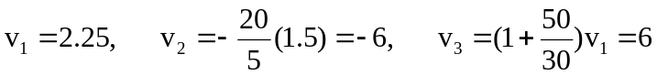
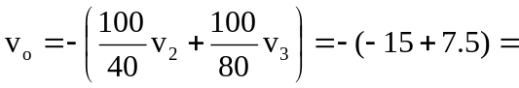7.5 V.

